 | Universidad de Oviedo  TSC-UNIOVI  Signal Theory and Communications Group (Grupo de Teoría de la Señal y Comunicaciones) |  |  |  |  |  | 
Project: INVEMTA
"INVerse ElectroMagnetism Techniques with Application to near-field diagnosis, imaging and location - INVEMTA” (Técnicas de Electromagnetismo Inverso con Aplicación al diagnóstico, reconstrucción de geometría y localización - INVEMTA)
TEC2008-01638
- Research topics

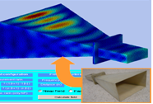  Inverse electromagnetic radiation techniques with some innovative Near-Field (NF) algorithms and applications and experimental setups using antenna measurement facilities. Full-wave integral equation formulations. Source Reconstruction Method (SRM). Improvements and applications in antenna diagnosis (probe correction, phase retrieval, determination of safety volumes of radioelectric stations, super resolution for diagnosis of metamaterial based antennas). |  |  |  | 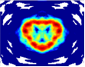  Study of inverse scattering methods based on integral equation formulation for material characterization, low-contrast object imaging and arbitrary geometry imaging and material reconstruction.
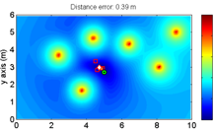  Cooperative location technique for indoor scenarios based on the strategy and formulation of the SRM. The influence of obstacles, number of sensors, multifrequency information and EM noise. Experimental validation of accuracy and usability study of the algorithms using 802.15.4 PHY link ZigBee network for Received Signal Strength (RSS) configuration. Multifrequency and phase information through the integration of appropriate RF multiband transceivers. |  |  | Antenna NF pattern synthesis NF based on data learning and self-calibration methods. Application to an NF UHF RFID tag reading system.  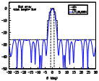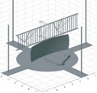
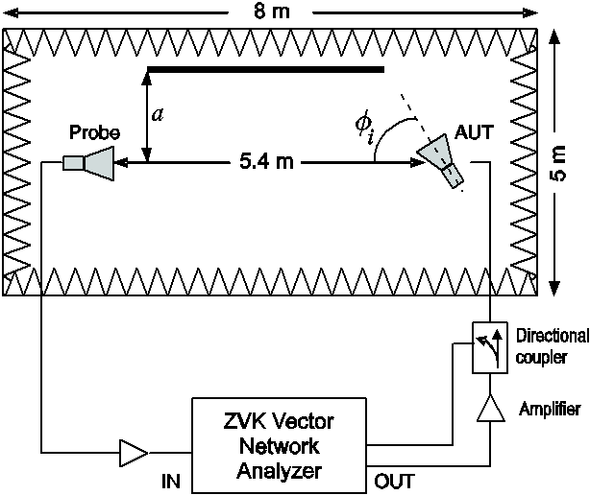  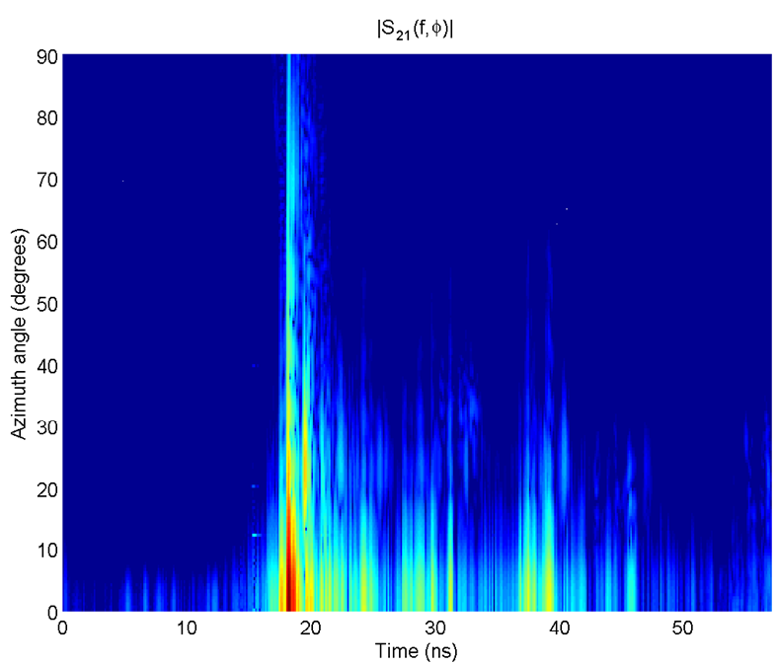  Spectral angular echo cancellation techniques optimization regarding necessary bandwidth. Support Vector Regression (SVR) techniques implementation in NF configurations and its extension to the knowledge of only amplitude information for low-cost measurement ranges. |  |  |  |  | 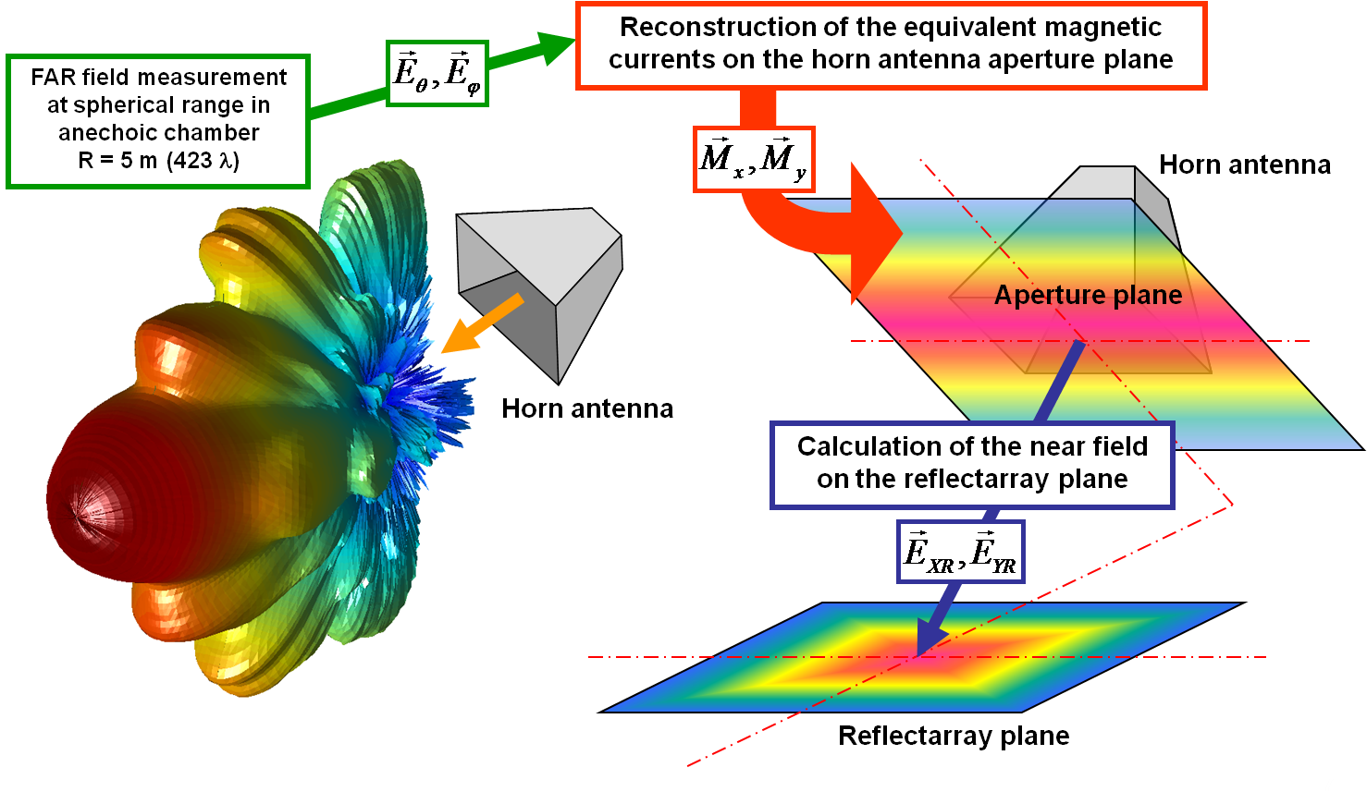  Reflectarrays antennas design using the SRM to characterize the real feeder. Reflectarray diagnostics. Benchmarking of reflectarray design techniques.
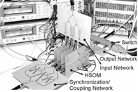
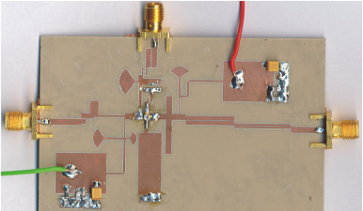
RF/microwave circuitry for practical implementation of some of the previous tasks: oscillator based multi-carrier transceiver sensors, compact multiband antennas for the proposed full-wave location techniques; development of injection-locked harmonic self-oscillating mixer (HSOM) circuits for their implementation in different types of active antennas. Nonlinear analysis and optimization techniques for the design of rationally injection locked oscillators and harmonic balance and transient envelope simulation.

